Create a simple console program in visual C#
For most of the exercises (and homework projects) that you work with in this class, you will normally be given a 'starter project', that contains everything you need to get you started on the exercise/homework assignment. However, it's good for you to know how to create a new project from scratch. Go through this exercise, in order to make sure that you're comfortable with creating, compiling, and running (executing) a C# program that you've created yourself.
It is possible to quickly and easily create several different types of applications using visual C#. We will start by creating what is called a console application -- the steps specified here are largely adapted from those found in your textbook in Chapter 2 – the major difference is that your textbook doesn't use the Visual Studio.Net development environment, but instead uses the .Net SDK & the command line. While you're welcome to try out how the book does things, I'd strongly recommend that you familiarize yourself with VS.Net, instead.

Start Microsoft Visual Studio.Net. It is located in the Start menu at

All Programs>Microsoft Visual Studio.Net 2003>Microsoft Visual Studio.Net 2003
We’ll be using Microsoft's Visual C# compiler that this quarter. It is an integrated environment that allows you to edit, build and run C# programs. You’ll learn more about it as the quarter progresses.

Create a new project. Select File>New>Project from the VS.Net menu bar. This brings up the New Project window that allows you to select from various items to create, which should look like the one pictured below. In the Project Types window (left-hand pane), you want to pick Visual C# Projects.
Once you've done that, you want to select from the Templates window the Console Application (note that you'll have to scroll down to find it). You also must type in a project name (such as "Lecture1_Exercise2") and select the directory location where you want the project to be stored. If you're working at school, you'll wants to store the project in your student folder (H:\, if available) or on your own removable media. Click Ok and you'll go to the next step.
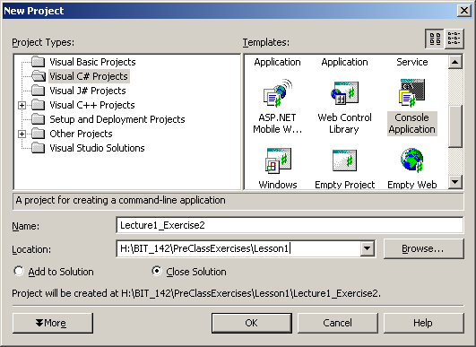

You just created C# project, and a C# files containing a nearly-blank program. Projects store information about all of the files and options that are used to create a C# program. Files are typically C# source files that have a .cs extension and contain executable C# statements, although there are other file types.
If you examine the code (most of which is explained well by the Deitel book), you'll find a line that reads:
// TODO: Add code to start application here

You want to replace that, with the following boldfaced code, so that the entire file looks exactly like the following:

using System;

namespace Lecture1_Exercise2
{
/// <summary>
/// Summary description for Class1.
/// </summary>
class Class1
{
/// <summary>
/// The main entry point for the application.
/// </summary>
[STAThread]
static void Main(string[] args)
{
Console.WriteLine("Hello, World!");
}
}
}
You should get into the habit of saving or files often, so that you do not lose work for any reason (technically, once you build your program, Visual Studio will save your files for you, but it is still a good reflex to have)

Select Build>Build Solution from the VS.Net menu bar. This will create an executable program from the source file class1.cs.

Select Debug>Start from the VS.Net menu bar. The program will run and you will see a new window with the words “Hello, World!” displayed, which will immediately disappear. This is because you've told VS.Net to start the program, using a program called a debugger. The debugger was never told to stop the program anywhere, so it ran the program, which printed hello, and then finished. Once the program finished, the window disappears.
You should try selecting Debug>Start Without Debugging, in which case you'll note that the window won't disappear immediately. VS.Net will run the program directly (without the help of the debugger), and when the program finishes (which is does immediately), will then wait for you to push a key before taking down the window.

If you’re using an ‘Express’ version of Visual Studio you may not find the ‘Start Without Debugging’ option. If so, try the following (this may not work on all versions of Visual Studio)
Under the ‘Tools’ menu, under the ‘Settings’ submenu, select Expert (instead of Basic), as pictured here:
