Overview:
- Instructor sets up repo
- Student sets up BitBucket account
- Student navigates to instructor's repo
- Student FORKS that repo
  - Do NOT clone this
  - Forking will create a new repo under the student's account, will save the instructor's history, and will preserve the connection between the student & instructor's repo so that the student can later issue a pull request
  - BitBucket.org's forking doc page: https://confluence.atlassian.com/bitbucket/forking-a-repository-221449527.html
- Student sets up git locally
- Student then clones their own repo from BitBucket onto their local machine (their personal computer)
- Student does work locally, committing work as they go
- When the student is ready to hand stuff in, they push their committed work back to the student's repo on BitBucket
- On the BitBucket website, the student creates a pull request to actually send the work to the instructor

IDEA: Color-code background of this document based on whether you're supposed to be on the website or on the local computer?
First, create a new repo:
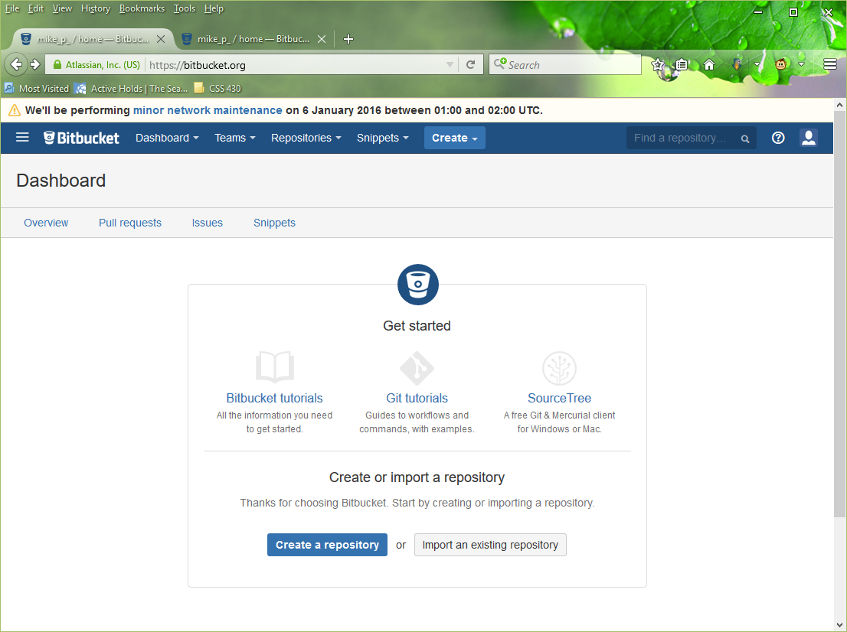
If you need to do this later on then you'll need to use the Repositories menu instead:
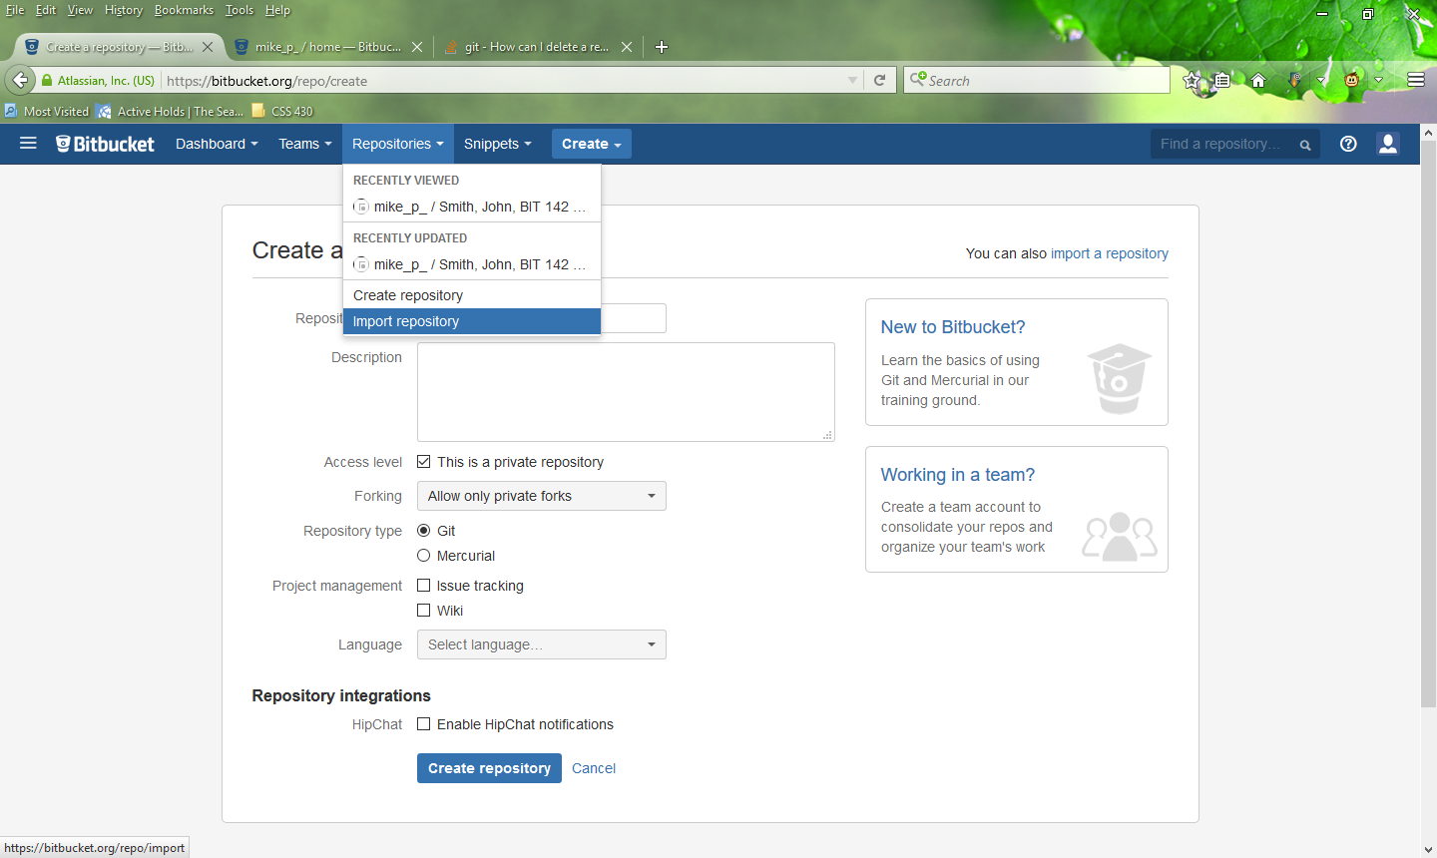

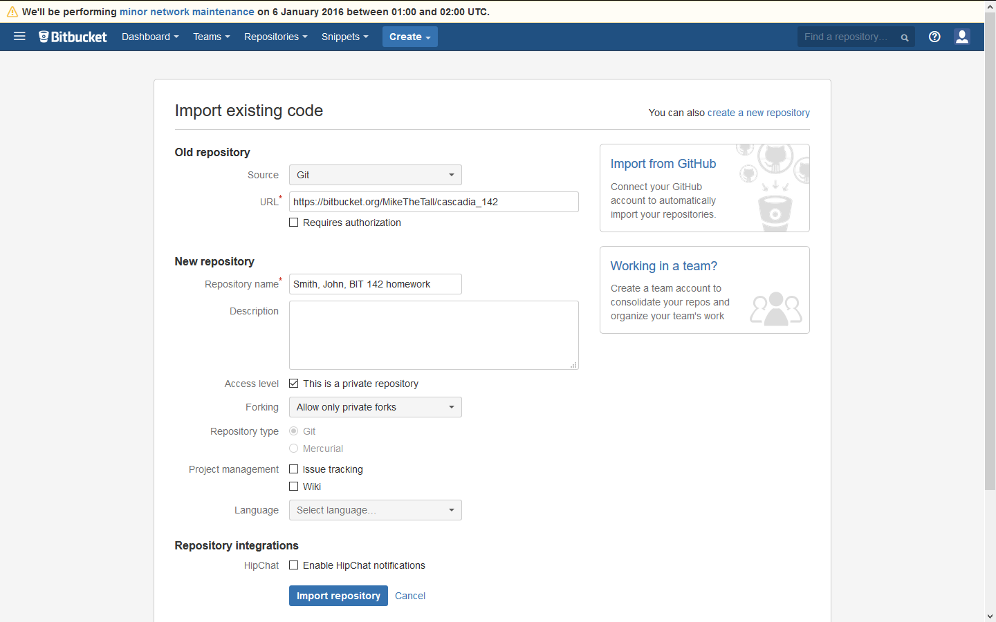

You should then see this:
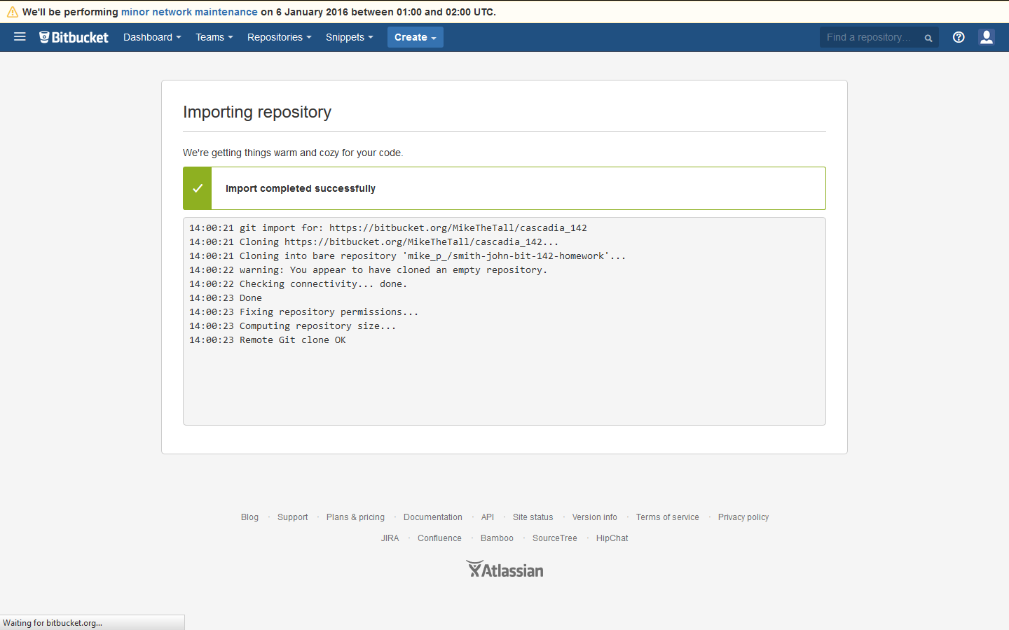
You will then be automatically redirected to the 'Overview' page for your new repo:
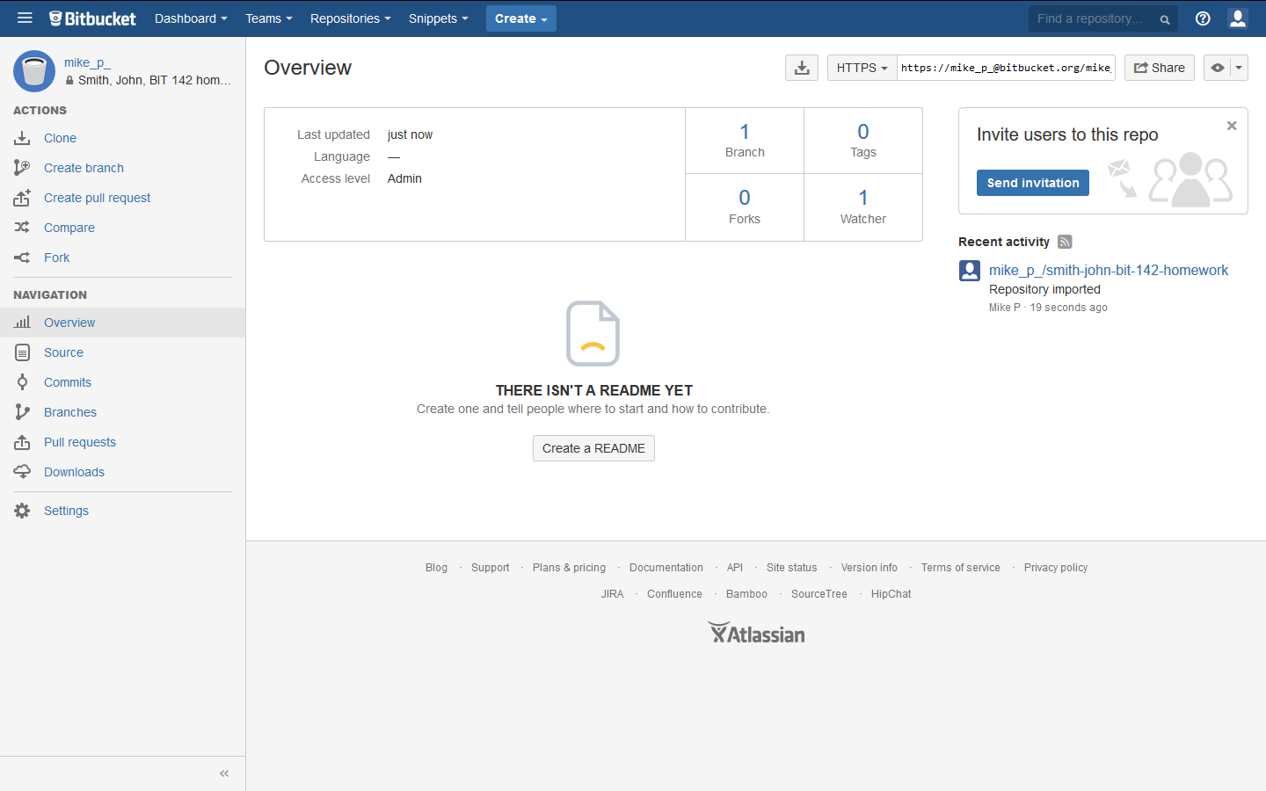

Create pull request:
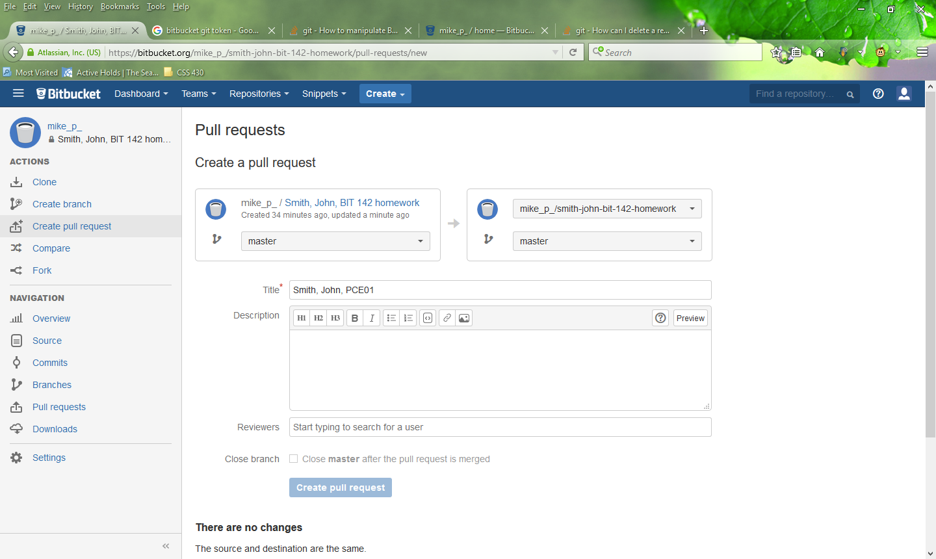
Default repo details are fine, but change the title to "Lastname, Firstname, What you're submitting"

