Math 120 Notes 8.8 – Phase Shift and Sinusoidal Regression

I. Phase shift.
A. Graph the following in addition to 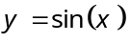 on the calculator. Identify any patterns.
1. 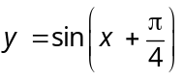 2. 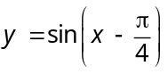 3. 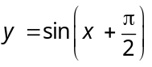

B. How do we move the sine function left and right?
C. Find the function that transforms the function 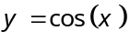 by
1. Shifting 40° to the right.
2. Shifting π to the left, and having an amplitude of 4.
3. Shifting π/6 to the right, having an amplitude of ¾, and reflecting across the x-axis.

II. Phase shift and period
A. If the function is in the form 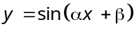, how do we find the period and phase shift?
B. For each of the following functions, identify the [a] amplitude, [b] period, [c] phase shift, [d] vertical shift, and [e] reflection.
1. 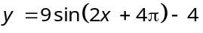 2. 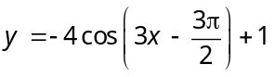
3. 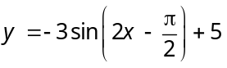 4. 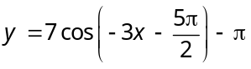
C. Use the trig graphs below to graph the following equations
1. 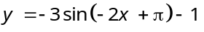 2. 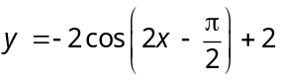
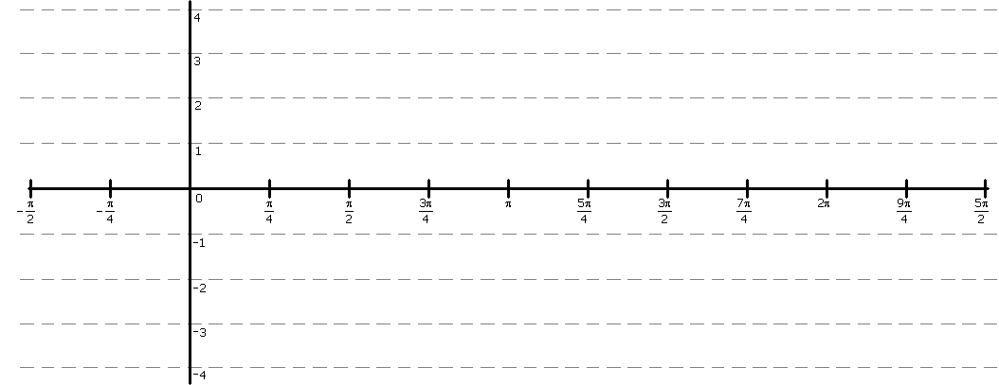

III. Periodic data
A. Review linear regression on other sheet.
B. Applications
Temperature
1. The following data shows the average temperature at Bothell, WA.
month | Bothell, WA
1 | 41
2 | 43
3 | 46
4 | 50
5 | 56
6 | 61
7 | 65
8 | 66
9 | 62
10 | 53
11 | 46
12 | 41

a. Graph the temperature for Bothell, WA for the year.
b. Use the graph to predict the temperature for today.
c. On what day number does the temperature reach a maximum?

Daylight
2. The following data shows the sunrise times at Bothell, WA.
month | Bothell, WA  Sunrise
1 | 7:57
2 | 7:36
3 | 6:50
4 | 5:48
5 | 5:51
6 | 5:14
7 | 5:14
8 | 5:45
9 | 6:27
10 | 7:07
11 | 6:53
12 | 7:36

a. Graph the sunrise time for the year.
b. Use the graph to predict the time the sun rose today.
c. On what month and day does the sun rise the earliest?

