Math 120 Notes 8.6 – Graphs of the Trig Functions

I. Graph sin(x) and cos(x) using the graph paper supplied.
A. Identify key points on the graph.
B. What is the amplitude of the graph? What is the period? Where is the midline? What is the range?

II. Amplitude changes.
A. What is the amplitude of sin(x) and cos(x)? How can you change the amplitude by modifying the equation? What does a negative do?
B. Identify the amplitude of the following functions
1. 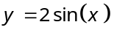 2. 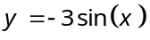 3. 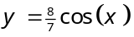
C. Match the following graphs with the equations below.
1. 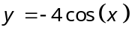 2. 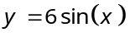 3. 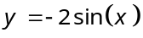
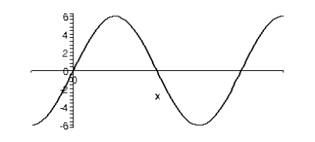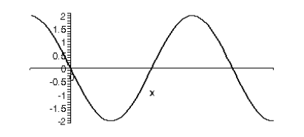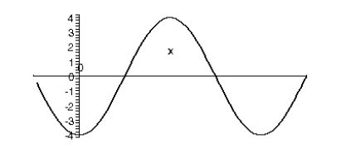
A
B
C
D. Use the trig graphs below to graph the following equations
1. 2.
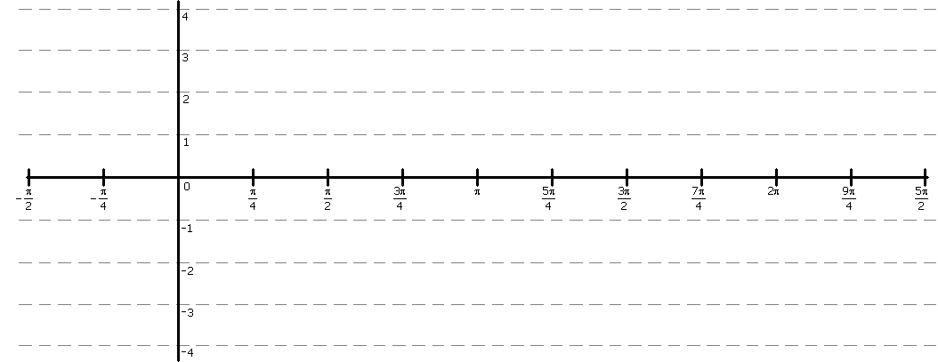

III. Period changes.
A. What is the period for sin(x) and cos(x)? How can we change that using the equation?
B. Identify the period of the following functions
1. 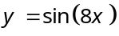 2. 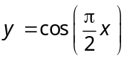 3. 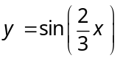
C. Match the following graphs with the equations below.
1. 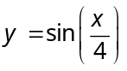 2. 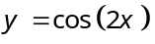 3.
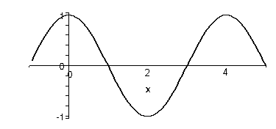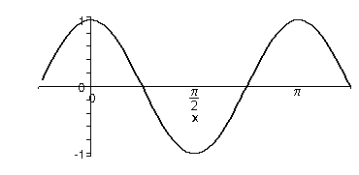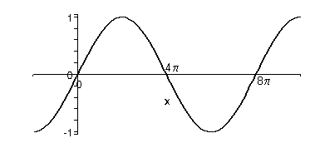
C
B
A
D. Use the trig graphs below to graph the following equations
1. 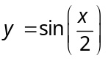 2.

IV. Vertical shift
A. How do you change the midline in trig functions?
B. Use the trig graphs below to graph the following equations
1. 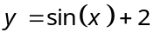 2. 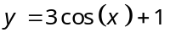
3. 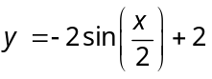 4. 

