Graphs of Sine, Cosine Functions

Describing sinusoidal curves with Amplitude, Period, Phase Shift
1) Find the amplitude, period, and phase shift of each equation, then graph it, showing at least one period (cycle).
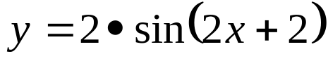
(Remember that phase shift is the same as C, and that you might have to do some math to put the above equation into the familiar 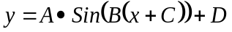 format)

Amplitude:

Period:

Phase Shift:

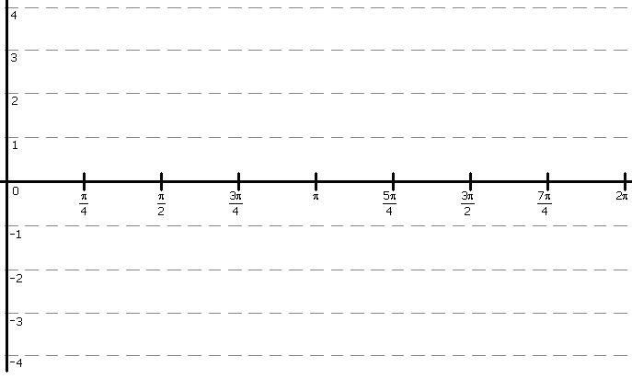

Describing sinusoidal curves with Amplitude, Period, Phase Shift
2) Write out an equation of a sine function, given the following characteristics, then graph it.
Amplitude: 3 Period: 2π Phase Shift: 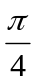

3) Write out an equation of a sine function, given the following characteristics, then graph it.
Amplitude: 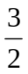 Period: π Phase Shift: 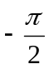

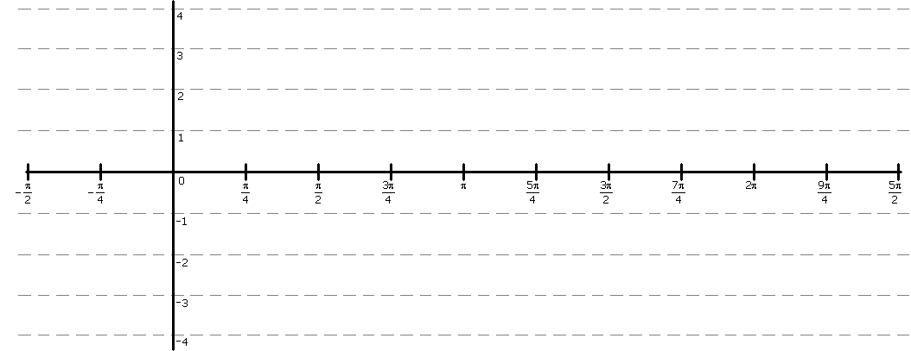
Modeling Using Sinusoidal Regressions
Goal: Given some data, find a sinusoidal function (if one exists) for it, with the help of your calculator.
For each of the following exercises, you should follow these steps:

- Turn your calculator’s diagnostics on
Press for the Catalog option, then press (for the yellow D, above it). Push the down arrow until you get to DiagnosticOn, then press . That gets you back to the home screen. Press again to actually turn the diagnostics on. You only need to do this ONCE, but it’s not bad to get the practice of doing this.

- Input the data into your calculator
On the TI-83, use the key, then select Edit, which is what you start at. Add the data to lists L₁ and L₂. You should add your "X" data to the L₁ list, and your "Y" data to the L₂ list.
When you're done, you should be able to read down the columns, and see (X,Y) on the same row, with X under the L₁ list, and Y under the L₂ list.
- Graph the points (scatter plot)
On the TI-83, use the keys, select Plot1, which is what you start at. Select On, then press .

- Fit the Sine Curve To the Data
Using what you know about fitting sine curves to points, figure out what the equation must be. As you're working, put your 'rough drafts' of the equation into the calculator, so you can see if it looks right, before you do the work of typing in the whole thing.
Remember that if you want to INSert something into your equation, rather than overwriting what's there, you should push the key in order to access the INS functionality (in yellow).

4) Enter the following data, and draw a scatter plot from it, and then finally figure out the equation, in terms of amplitude, vertical shift, period, and phase shift.

Month | X value we'll use to represent the month | Average Temperature,  in F°
Jan |  | 29.7
Feb |  | 33.4
Mar |  | 39.0
Apr |  | 48.2
May |  | 57.2
Jun |  | 66.9
Jul |  | 73.5
Aug |  | 71.4
Sep |  | 62.3
Oct |  | 51.4
Nov |  | 39.0
Dev |  | 31.0

First plot the above data points on your calculator. This will allow you to visually confirm that the data is, indeed, periodic, and looks like a sine wave.

Next, calculate the vertical stretch (the amplitude), vertical shift, horizontal stretch, and horizontal offset, using what you know.
As you calculate each, try graphing your sin function with that new number, so as to confirm that it looks right (i.e., double-check your work as you go).

Write out all your work, and the final equation, here:

