Graphs of (Co)Tangent, Co(Secant) Functions

Graphing Tan, Cot with the help of the Unit Circle
1) The first thing we'll need are the two special triangles from which we can get many common ratios for trigonometric functions. Given the following two, blank, triangles, fill in all the angles (with degrees and radians), and the lengths of each side:
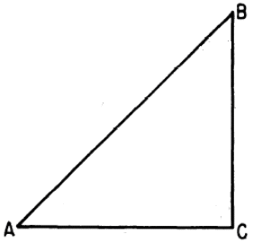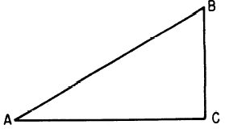
2) Draw in degrees, radians, and the value of the Tan function, for each line that's been drawn onto the unit circle:

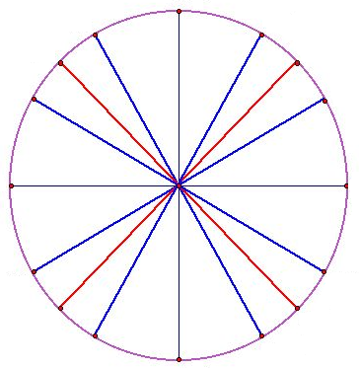

3) Plot the (x,y) values of y = Tan(x), for each tick mark on the X axis. Hint: Where tan(x) is undefined, there is a vertical asymptote (line that does not get crossed)
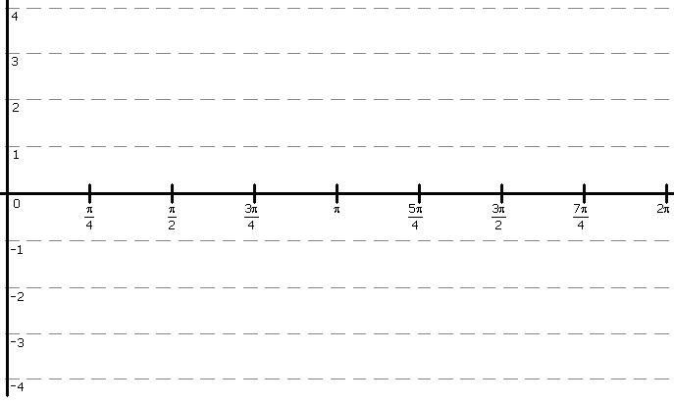
4) Plot the (x,y) values of y = Cot(x), for each tick mark on the X axis. Hint: Where Cot(x) is undefined, there is a vertical asymptote (line that does not get crossed)
Graphing With Transformations: Tan, Cot
5) Given the following equation, graph it on the provide space, using transformations to properly place the graph: y = Tan(x + π) + 2
6) Graph y = 2•Tan( ½ • x) - 1

Graphing With Transformations: Csc, Sec
7) Graph the following equation: 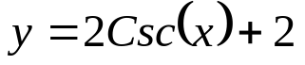
8) Graph the following equation: 

