:
What you handed in appears to be identical to the starting project. If I missed the work that you did please let me know ASAP (email is great). If you handed in the wrong thing you can still hand in your work by using an extension. To do this you must upload your work to StudentTracker into the “Assignment 3 Revision” slot within 24 hours of when I emailed out this feedback. If you do this please email me to let me know so I can go find and grade it.
And, if you don’t want to do either of the above two options I’m going to leave this rubric here to help guide your work on the final, revised version.

Overall:
- Looks good.

Working Around Problems:
- This looks good - you have both a plan to work around the problem ‘right now’ and you’ve got some ideas what you might do in a work environment.
- I did not find a comment, located at the top of the Program.cs file, that explains what the compile-time problem was and how you worked around it AND how you'd react to this situation in a real-life/professional work environment. (-6)
Book-Tracking Application:
- You haven’t filled in error-handling code (-15)
In the Add and Remove options, make sure to give the user confirmation feedback when things go ok, too.
- In the Add and Remove options, make sure your error-handling code gives the user confirmation feedback when things go ok, too (-5)
- Looks good.

Class for a node in the ‘Author List’:
- This is missing entirely. (-30)
(You should model the nodes in the ‘author’ list using a class)
- Put a constructor on this, so you can create Author objects in a single line. (-3)
- Since the class is a private nested class you can (and should!) make the instance variables public. (And remove any get/set methods, too) (-3)
- You don't have a string field that stores the author’s name. (-3)
- You don’t have a variable for the first node in the book list for this author.
(In other words, if Author “A” has books 1, 2, and 3, then you need a reference from Author “A”’s object to Book 1’s object) (-6)
- Looks good.

Class for a node in the ‘Book List’:
- This is missing entirely. (-30)
(You should model the individual books using a class)
- Since the class is a private nested class you can (and should!) make the instance variables public. (And remove any get/set methods, too) (-3)
- Put a constructor on this, so you can create Book objects in a single line. (-3)
- You don’t need an ‘author’ field here, since you’re going to attach the books to an author object (-6)
- You don't have a string field that stores the title. (-3)
- You don't have a field that stores the price. (-3)
- You only need a ‘next’ pointer (in the Node class) – you do NOT need a nextAuthor pointer and a nextTitle pointer. (-3)
- Remove the ‘book’ prefix from the instance variables. You know that it’s part of the book object because they’re instance variables on the Book class. (-3)
- Add a Print method so you can call it from the MultiLinkedList.Print method. (-3)
- The Book's Print method should live here, not on the MultiLinkedList class. (-3)
- Looks good.

Multi-List class
- The basic structure for the lists in this assignment is that the MultiLinkedList has a reference to the first author in the collection (in the picture below, the author is Stephen Baxter).
That author has a reference to the author’s first book (i.e., Stephen Baxter wrote both “Flood” and “Manifold: Origin”. Since “Flood” comes first alphabetically you need to keep a ‘first book’ point from the “Stephen Baxter” author over to the “Flood” book).
That first book has a reference to the next book in the list (in this example it’s “Manifold: Origin”). (-30)
Your approach appears to use a single list of all the books, instead.
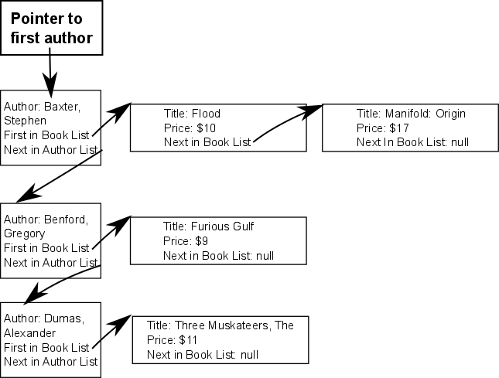
- You should have a single ‘firstAuthor’ instance variable (you do NOT need the firstTitle variable) (-6)
- Add: don’t create the new Author object until you know that you need it (if the author already has an entry in the list you’ll just throw the object away) (-3)
- Don’t create variables that are aliases for the first author reference. (-3)
(Just use firstAuthor directly, so it’s clear that you’re intentionally doing something with the first book in the list)
- Add: Move the code for adding the new node to the very front of the list outside of the loop so that it only runs once (instead of checking for this every time the loop runs) (-6)
- Add: You don’t have any code to add the author to the very front of a non-empty list.
(-6)
- Add: You don’t have any code to add the author to the middle of the list (-6)
- Add: You don’t need a separate case for a single-item list. Merge this into your ‘middle-or-end-of-the-list’ logic; doing so will simplify your code substantially.
(-6)
- Add: refactor your ‘add book to the book list’ code so that you don’t have to copy-and-paste this (i.e., put it into a method, or else rearrange your code so that you only need to have a single copy of the code) (-6)
- Add: You don’t detect duplicates (-6)
- In Add, incorporate the check for a duplicate into the ‘adding a book’ loop. This way, you won’t have to go through the list twice. (-3)
- Add: This will crash if you add a book to the very end of the list (-6)
- When adding a book into the middle of (either) list, you can combine the code for your two cases (i.e., you can use the same code for 'adding at the end of the list', and 'adding between two existing elements' (-3)
- Add: If the author already has an entry in the ‘author’ list you should just re-use that object, instead of adding another author object (-6)
- You don't provide a Print method. (-15)
- You don't provide a Print method that works with the above structure. (-10)
(Instead, your Print method works the with prior quarter’s assignment)
- You don't provide a RemoveBook method. (-30)
- Remove: This needs to first find the author node (if it exists). If the author node does exist then the next step is to remove the book. If that was the last book (i.e., this author now has no books in the system) then you must remove the author from the author list, too. (-20)
- Remove: This should return an ErrorCode and NOT print anything (-3)
- Find a way to implement the Remove method that doesn’t involve creating a new book object each time you want to remove something – Either another version of the Compare methods on the book class, or else an instance variable on the List class that you re-set each time. (-3)
- In Remove, refactor the “is the book identical to author & title” to a method on the book class (or re-use the CompareByAuthor/Title” method, instead of duplicating this again here. (-3)
- Remove (and elsewhere): on lines you create a local variable named copy. This is the same as firstAuthor on these lines. It’s confusing to create a new name for something you’ve already got, so on these lines just refer to firstAuthor directly (instead of using the local variable you just created) (-6)
- Remove: If you remove the last book by an author, then you need to go back and remove the author from the author list, too. (-6)
- In the Remove method, you should look for an exact match in the title list (i.e., same title AND same author), then remove the exact match from the title list. (-6)
- In your Remove method, you can (and should) end before traversing the entire list, since the lists are stored in sorted order. (-3)
- Remove unused/ commented out code before handing this in (-3)
- Except for methods whose purpose is specifically to interact with the user (such as PrintByAuthor/Title), this class shouldn't produce any I/O. Instead, return a value to the calling method, and then use that to figure out what main should print.) (-3)
- Looks good.

Grade (out of 130):

To calculate your grade: add up all the (-1)'s and (-6)'s and (-X)'s, to get some negative number, then take that from the total to get your grade. For example: If the total points available for the assignment was 100, and you had the following penalties: -3 + -6 + -6 -15, so the grade would be 100 -15 = 85.
Why do you have to do this? Because this is only version 1, and so you won't really get your 'real grade' until you hand in the revision. Sometimes the grade on this first version appears really low (especially if you left out a whole section), and so I want to give people feedback, but try to avoid spooking people. Keep in mind that if you don't hand in a revision, this will be your final grade.

Why do you have to do this? Because this is only version 1, and so you won't really get your 'real grade' until you hand in the revision. Sometimes the grade on this first version appears really low (especially if you left out a whole section), and so I want to give people feedback, but try to avoid spooking people. Keep in mind that if you don't hand in a revision, this will be your final grade.

Numbers that are 'greyed out' don't count (i.e., the item is there for informational purposes, to preemptively give you feedback for your revision), but these don't actually represent points that you've lost. Example of a 'greyed out' item:
You didn't do X. (-3)

Note: Please note that if any of the above errors are duplicated within your code, you need to fix ALL INSTANCES of the error, even if it's not specifically listed above, in order to get the points.

