Downloading and Using a simple console program in Visual C#

In this class you may be asked to download and use a provided ‘starter project’, so that instead of writing everything yourself, from scratch, you will instead be given an existing project, and some code, and you will have to extend, rather than starting from scratch. This document will give you some quick pointers about how to obtain such a project.
Before reading this, you will need to know what a ‘project’ is. Make sure that you’ve read the document, watched the video, and tried creating your own C# project (in the other, separate exercise) before doing this one.
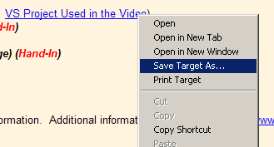
- Download the project
Find the link (on the website) the project that you want to download. The safest way to actually download it is to RIGHT-CLICK on the link, and then select ‘Save Target As…’ from the context menu that appears, as pictured to the left

You will then be asked where you want to save the project. Save it someplace appropriate, and remember where you put it. Notice that you are downloading a single file (which typically ends with .ZIP, if you’ve set up Windows to show you the file extensions)
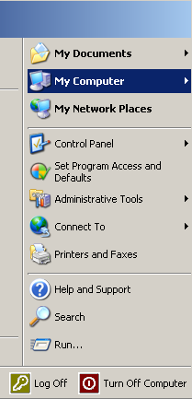
- Decompress the project
Open up a ‘file system browser’ by doing something like Start My Computer (in the right column, as pictured to the right). Navigate to the place where you put the .ZIP, right-click on that, and select one of the “Extract” options. This will decompress, and separate out, each of the individual files that are included in the single .ZIP file.

- Open up the project, and get to work!
Find the ‘Solution’ file, or the ‘Project’ file. If you just extracted everything, this may be in a subdirectory. Double-click it, and it should open up in your Visual Studio/Visual C# Express/etc environment.

- Re-compress to hand it in
Once you’re done, you can have Windows re-compress everything into a .ZIP file. RIGHT-CLICK on the folder that contains all your work, and select “Send To”, then “Compressed Folder”, as pictured below:
