Multi-Project Starter Solutions

The goal for this exercise is to make sure that you can use the provide starter solutions, which may contain multiple projects within one solution.

Here in BIT 143, it will sometimes be awkward to put all of a lesson's exercises into a single .CS file. If that is the case, the starter project will contain all the exercises in a single solution, using separate projects for separate exercises. However, if you are asked to add code to an existing solution, and you can reasonably, easily combine several exercises in a single file (within a single project), please do so.

Download this week's starter project, and open it. When you open it, you'll notice that there are actually multiple projects within the overall solution. You can see this by looking at all the files in the solution: click on
View Solution Explorer, and you should see something like the following:

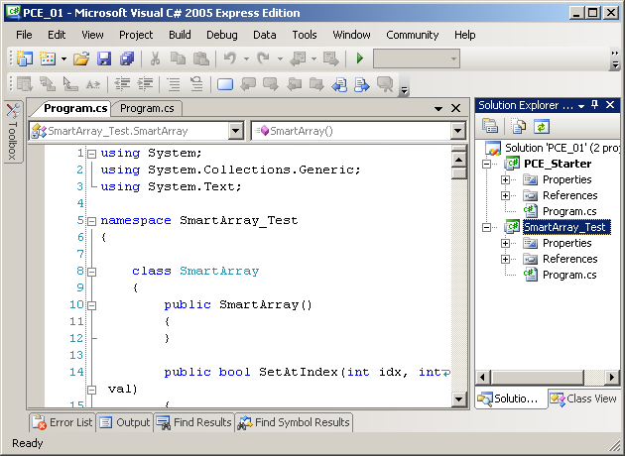

You'll notice that on the right-hand side of the screen, in the Solution Explorer panel, that there's a solution (in this case, PCE_01). Underneath that, there are two projects –PCE_Starter and SmartArray_Test. You'll notice that PCE_Starter is in BOLD. This means that it's the 'active' project. If you tell Visual Studio to run the current project (using Debug Start Without Debugging, or Debug Start Debugging), it will start running the program that starts in the public static void Main(string[] args) method in the PCE_Starter project. Try it, and you'll see that after building all the projects, PCE_Starter is the one that gets run.

Note that if you select Build Build Solution, Visual Studio will attempt to build all the projects that are contained within your overall solution.
If you want to change the currently active project, you can simply right-click on the other project, then select "Set as StartUp Project", as shown here:

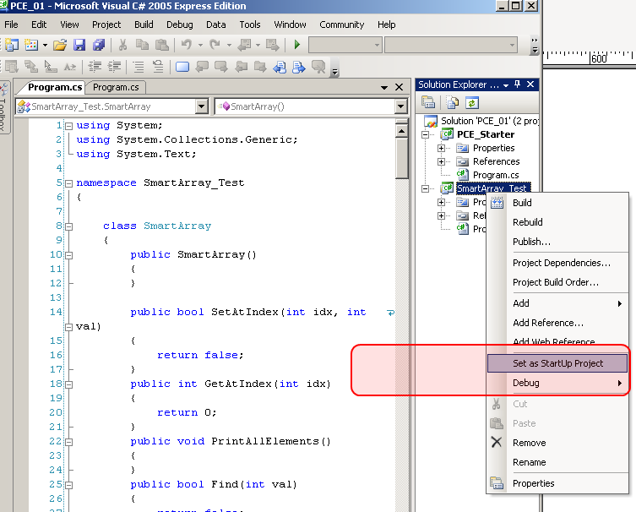

once you've done that, then you can run the main method in the other project, using the same Debug Start … menu item that you used previously.

The main thing to take away from all this is that if the provided starter solution contains multiple projects, you may need to set different projects as StartUp Projects, in order to run the code that you want.

What you need to do for this exercise:

You need to be able to everything described above.

There is nothing that you are required to hand in for this exercise.

