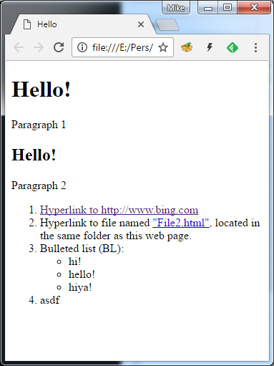
Question:

Within the file below, you will some empty space. Fill it in with whatever you need to in order to make it look like the picture to the right
<!doctype html> <html lang="en"> <head> <meta charset="utf-8">
<!—odd (but legal) indentation saves space on quizzes -->

</body></html>
Question:

Within the file below, you will find several empty boxes. Fill in the boxes with whatever code you need to in order to make sure that the page does the following:
When the user clicks on the button the page should pop up an alert box greeting the user. You’re welcome to choose your own greeting as long as you choose something that’s workplace appropriate.
<!doctype html> <html lang="en"> <head> <meta charset="utf-8">
<!—odd (but legal) indentation saves space on quizzes -->
<title>jQuery02 Example File</title>
<script src="http://ajax.googleapis.com/ajax/libs/jquery/1.10.2/jquery.min.js"></script>
<script>
$( ).ready(function() {

$("#theButton"). ( function() {

});
});
</script></head><body> <h2>jQuery 03 Example File</h2> <form>
<input type="button" value="Click here" id= >

</form></body></html>

Question:

Within the file below, you will find some empty space. Add whatever you need to so that:
- The h2 heading should be twice height of a normal line
- The paragraph that contains the text “GREEN TEXT” should show the text using green letters.
- The paragraph that contains the text “LOOKS RED” should highlight the text in red.
<!doctype html> <html lang="en"> <head> <meta charset="utf-8">
<style>

</style></head><body>
<h2>jQuery 03 Example File</h2> <form>
<p id=”testPrep1”>GREEN TEXT</p>
<p class=”RedHighlight”>LOOKS RED</p>
<p >La la la, text goes here</p>
<p class=”RedHighlight”> LOOKS RED </p>
</body></html>
Question:
Within the file below, you will find several empty boxes. Fill in the boxes with whatever code you need to in order to make sure that the page does the following:
First, the page should verify that the user has typed in a number. If the user didn't, then the page should display a message saying that the user needs to type in a whole number and then stop.
When the user fills in an hour (a number between 1 and 24) and then clicks on the button the page will display a message in the paragraph with the id of "msgHere". If the hour is less than 12 the message should be "Good Morning", if it's ≥ 12 then the message should be "Good day".
<!doctype html> <html lang="en"> <head>
<!-- I'm leaving out the boilerplate stuff (like the part that loads jQuery in order to save space on the page -->

<script type="text/javascript">
$(document).ready(function() {
$("#demoMultiway").click( function() {
// start by getting what the user typed in:
var hour = ;

hour = parseFloat(hour);
if( )

{
$("#msgHere").html( "You didn't type a number!");
;

}
var show; // this is the message to show
// decide which message to show:
if ( )

{
show = "Good morning";
}
else
{
show = "Good day";
}
// display the contents of 'show' on the page:
( );

});
});
</script></head><body> <form>
<p>What hour is it? <input type="text" id="theHour" value="17"> <br/>
<input type="button" id="demoMultiway" value="MULTIWAY if...else statement demo"><br/></p></form>
<p id="msgHere">Some Fascinating Text! That I will change! With jQuery!</p>
</body></html>

Question:

Within the file below, you will find some empty space. Fill in the space so that When the user clicks on the button the page should read the number that the user typed into the textbox. The page should display an error message if the user typed something that wasn’t a number. If they did type in something that was a number, then the page should display that number AND that number + 4 on the page.
<!doctype html> <html lang="en"> <head> <meta charset="utf-8">
<!—odd (but legal) indentation saves space on quizzes -->
<title>jQuery02 Example File</title>
<script src="http://ajax.googleapis.com/ajax/libs/jquery/1.10.2/jquery.min.js"></script>
<script>

</script></head><body><form>
<input type="text" value="222" id="theInput">
<input type="button" value="Click here" id="theButton">
</form></body></html>

