Getting The Software
In order to be able to write programs in Java at home, you’ll need to obtain and install some software. It's all free for personal use, and you can freely download this software from the Internet.
You should anticipate spending as much as 2-4 hours to get all your software downloaded and installed correctly, more if you’re trying to download this stuff over a very slow connection. As such, you should allot enough time to both get all this software AND to actually do your first homework assignment. If you can’t get this to work, please ask and I’ll try and help out. If you have a laptop you are encouraged to bring the laptop to class so that the instructor can trouble-shoot any problems directly on your computer.

Remember that Cascadia provides virtual Windows computers that you can access through a web browser. In order to use these follow these steps:
- Direct your browser to https://desktop.cascadia.edu/
- Click on the ‘HTML’ version (because then you don’t need to install any software on your computer – it’ll all run within your browser)
- Log in using your normal Cascadia student username and password (just like you were logging onto a computer on campus)
- Select the ‘Student Floating View’ and patiently wait for the virtual computer to start up.
- At this point you should be off and running!

Remember also that Cascadia has public computer labs which you can use – if nothing else, you can always go there and use those computers. As such, I won’t accept excuses such as “My homework is late because I couldn’t install the software”

- Download the Java SE Development Kit (JDK)
(This step has already been done for you on the computers at Cascadia)
First, you need to get the free Java Development Kit (JDK).
We want to get the JDK that contains the product known as “Java SE 10”. (“SE” stands for “Standard Edition”.
Warning: there’s a Java Runtime Environment (JRE). This ISN’T enough – it will let you run Java programs that other people have created, but won’t let you create any on your own.
A link to the correct file to download is:
http://www.oracle.com/technetwork/java/javase/downloads/jdk10-downloads-4416644.html
(Oracle has decided to bury the Windows version of the JDK at the end of the list - it's the link that reads " jdk-10.0.2-windows-x64_bin.exe")
(You will need to click on the 'accept the agreement' radio button before doing the download)
Note that the website contains their most recent version of the software, so if they update the JDK and I don't notice, it'll be ok for you to get that newer version. Example: I tell you to get version 10.0.2, and they've replaced it with 10.2.5. As long as the numbers are equal to or higher the ones I specify, you should be fine (10.2.5 is 'bigger than' 10.0.2).
It’s also very important that you get (and install) the JDK first, since a number of other software packages require the JDK to be installed before them.
Lastly, if you previously installed a version of Java I’d recommend un-installing the prior version, then installing this version. If you do this, make sure to put the new JDK into the same location as your old one.
- Install the JDK
(This step has already been done for you on the computers at Cascadia)
Once you’ve downloaded the JDK, you should install it on your hard drive. I’d accept whatever defaults the JDK suggests in terms of location, etc.
- Bookmark the JDK documentation
(This step has already been done for you on the computers at Cascadia)
Oracle maintains documentation for Java programmers on-line at
https://docs.oracle.com/javase/10/
It’s good to bookmark this in your browser in case you want more details about Java
- Download the development environment: jGrasp
(This step has already been done for you on the computers at Cascadia)
Technically, you can develop Java programs using nothing more than the JDK, Notepad, and a command prompt. However, this can be tricky, so we’ll be using an Integrated Development Environment (IDE) to let us focus on writing Java, not on making the JDK do what we want.
We’ll be using the jGrasp IDE during class, and I’d recommend that you use the same software at home, as well. You can download a free version from:
http://spider.eng.auburn.edu/user-cgi/grasp/grasp.pl?;dl=download_jgrasp.html
Again, getting a version that is newer than Cascadia's shouldn't hurt. You should download the version that's appropriate for your operating system (for Windows, the top-most button, labeled jGRASP.exe, is what you want)
Once you’ve downloaded the IDE, you should then install it. It may need to be told where your JDK is (which you’ve already installed, right?).
For Advanced Students Only: You’re free to use any other IDE that you want – IntelliJ is very slick and well-respected. Eclipse has gotten good reviews, and is widely used in industry. The NetBeans project is also a solid choice.
If you choose to use anything other than jGRASP, you’re on your own if you run into problems. While I’ll try and offer help, I won’t really be able to guarantee anything. I can't guarantee that I'll be able to fix any problems you have at home, with jGRASP, either, but I do know more about jGrasp, and so can probably be of more help :)
- Download the Robot software
(This step is specific to BIT 115 - if you're in any other course then you don't have to do this step)
becker.jar (this file is stored in Canvas)
You’ll need some custom software in order to actually write programs that use the Java-based “Karel The Robot”. This version of the software was created by Byron Weber Becker, at the University of Waterloo in Canada. You'll need the becker.jar file listed above. Here at school, I would recommend placing it in your personal folders, which should be mapped to the H: drive letter. Further, I'd create a folder named BIT115, and within that, create a folder named Robot, and move the file there.
- Configure jGrasp for home use
If you're working on your own computer at home, you _have_ do this step. It's also listed in the In Class Exercises for Lecture 1, just so you don't forget!
During the 2018 Fall term, you may also need to do this for the computers at school, as well.

In addition to the functionality that standard Java gives us, we're going to use some custom software that will simulate robots. This software is found in the named becker.jar, which you downloaded when you installed all the other software. (JAR is short for Java ARchive, by the way.)

However, before you can write Java programs that use this, you need to tell JGrasp where to find the file. You do this by seting the classpath to make JGrasp locate becker.jar NONE OF YOUR PROGRAMS WILL WORK UNTIL YOU DO THIS. However, you will only need to do this ONCE – just the first time that you start JGrasp on a given machine.

To set the classpath, open the Settings menu and select the PATH / CLASSPATH option, and then finally the Workspace menu item (see Figure 4.) You will see a dialog window that resembles Figure 5. First click on the CLASSPATHS tab (not merely the PATHS tab), and then click the New button, and you'll see another dialog window that resembles Figure 6. Click on the button labeled Browse, and find the Becker.jar file that you've downloaded. Becker.jar contains all of the custom software that we'll need to simulate our robots. You may also add the documentation here, if you'd like, but you're not required to. When you click OK, you should an entry in the window, which is circled in blue in the Figure 5, below. Click OK button (circled in pink) to get back to the main editor window.

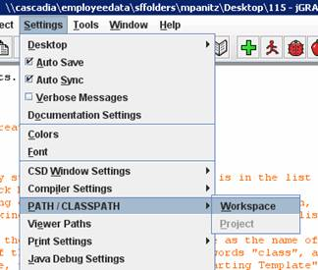
Figure 4

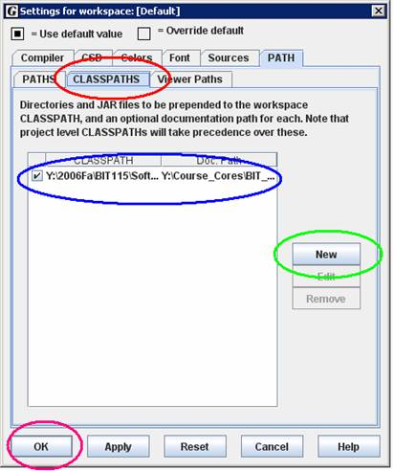
Figure 5
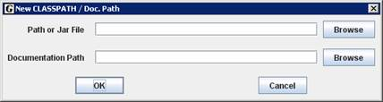
Figure 6
- Download a template for the first day
For the first day, you'll use a template to get you started. You will be expected to eventually be able to create an entire Java program from scratch (with no help from books, or your peers), but for the first day, you'll use a pre-written file to get you doing something interesting immediately. You can download that file from:
Starting_Template.java
Please save this file into the BIT115 folder that you created in Step 5. Make sure to keep the name of the file (Starting_Template.java) exactly the same.
Now you're ready to go on to the tutorial, where you'll start learning how to program!

