Blank City Template
Name:
City Name:
ICE# & Source Code File:

 | AVENUES
S  T  R  E  E  T  S | 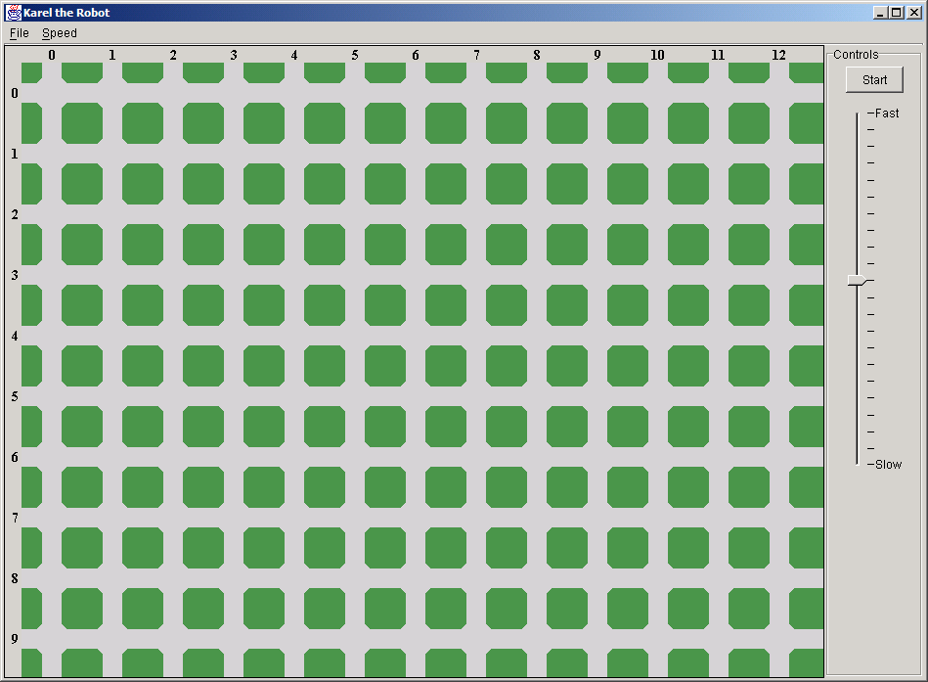

Remember:
AVENUES run NORTH-SOUTH; an avenue is a vertical road
STREETS run EAST-WEST; a street is a horizontal road

